**Portfolio Mean-Variance Analysis**

ChanJung Kim

1. Table of the mean returns and standard deviation of returns for the ten industry portfolios

|  |  |  |
| --- | --- | --- |
| Industry | Expected Return | Standard Deviation |
| NoDur | 0.902833 | 3.345657 |
| Durbl | 0.733333 | 8.361852 |
| Manuf | 1.012833 | 5.31027 |
| Enrgy | 1.231167 | 6.081524 |
| HiTec | 0.76625 | 5.381191 |
| Telcm | 0.881417 | 4.448284 |
| Shops | 0.916333 | 4.093786 |
| Hlth | 0.783833 | 3.787172 |
| Utils | 0.907167 | 3.701763 |
| Other | 0.489083 | 5.582452 |

|  |  |  |  |  |  |  |  |  |  |  |
| --- | --- | --- | --- | --- | --- | --- | --- | --- | --- | --- |
|  | **NoDur** | **Durbl** | **Manuf** | **Enrgy** | **HiTec** | **Telcm** | **Shops** | **Hlth** | **Utils** | **Other** |
| **NoDur** | 11.193422 | 18.449666 | 14.104907 | 10.531341 | 12.922949 | 11.968078 | 10.170832 | 9.953112 | 7.866653 | 14.438409 |
| **Durbl** | 18.449666 | 69.920577 | 39.178097 | 27.019794 | 35.466652 | 27.490543 | 27.444731 | 16.824003 | 12.746136 | 39.361987 |
| **Manuf** | 14.104907 | 39.178097 | 28.19897 | 23.14538 | 24.618739 | 19.55015 | 17.622867 | 13.596447 | 11.440612 | 26.313423 |
| **Enrgy** | 10.531341 | 27.019794 | 23.14538 | 36.984933 | 19.267276 | 15.366817 | 11.2978 | 9.630327 | 14.027168 | 18.320469 |
| **HiTec** | 12.922949 | 35.466652 | 24.618739 | 19.267276 | 28.95722 | 18.708273 | 17.837115 | 13.254064 | 10.304187 | 23.85547 |
| **Telcm** | 11.968078 | 27.490543 | 19.55015 | 15.366817 | 18.708273 | 19.787227 | 14.169356 | 11.506599 | 10.991596 | 19.610836 |
| **Shops** | 10.170832 | 27.444731 | 17.622867 | 11.2978 | 17.837115 | 14.169356 | 16.759084 | 10.178849 | 6.69435 | 19.226524 |
| **Hlth** | 9.953112 | 16.824003 | 13.596447 | 9.630327 | 13.254064 | 11.506599 | 10.178849 | 14.342669 | 7.475036 | 14.864553 |
| **Utils** | 7.866653 | 12.746136 | 11.440612 | 14.027168 | 10.304187 | 10.991596 | 6.69435 | 7.475036 | 13.703052 | 9.99296 |
| **Other** | 14.438409 | 39.361987 | 26.313423 | 18.320469 | 23.85547 | 19.610836 | 19.226524 | 14.864553 | 9.99296 | 31.163771 |

1. Covariance Matrix
2. Minimum-variance frontier and its economic significance

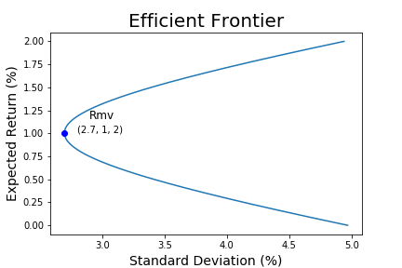

Efficient frontier is the set of the possible minimum variances given target returns. Given the target returns, variances are guaranteed to have smallest values on the parabola, meaning that all the portfolios can be located on the right-hand side of the curve. Investing in portfolios in the upper-half of efficient frontier maximizes their utility. The more risk-tolerant an investor is, the higher point the investor will choose in the curve. The lower-half of the curve can be ignored when making investment decisions, because for any given standard deviation, the upper-half of the curve will always yield higher return than the lower-half.

1. Efficient frontier with riskless asset, tangency portfolio and its economic significance

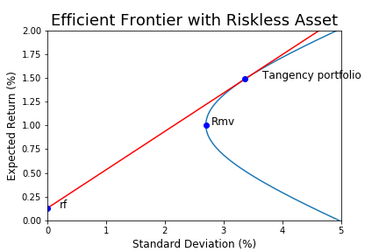

If riskless asset is included in the portfolio, the efficient frontier, a set of minimum variance point given the return is linear. Y-intercept of the efficient frontier denotes the return from the risk-free asset. At y-intercept, 100% of the his/her wealth is invested in risk-free asset. Likewise in the previous chart, the more risk-tolerant an investor is, the higher point the investor is likely to pick in the curve. ~~The proportion of risk-free assets decreases with the distance from the y-intercept.~~ At the tangent point, the portfolio consists of only risky assets, and it is called tangency portfolio. Above tangent point, the proportion of risk-free assets goes negative, and this implies that the investor takes a short position on risk-free asset.

1. Weight of ten industry portfolio at tangency portfolio

|  |  |
| --- | --- |
| **Industry** | **Weight** |
| NoDur | 0.5679722 |
| Durbl | -0.2140726 |
| Manuf | 0.7141051 |
| Enrgy | 0.1040872 |
| HiTec | -0.3634382 |
| Telcm | -0.0954633 |
| Shops | 0.9916468 |
| Hlth | 0.0755702 |
| Utils | 0.1326433 |
| Other | -0.9130508 |
| **Sum** | 1 |

The weight of each industry in tangency portfolio is as above. As mentioned previously, tangency portfolio does not contain risk-free asset making the sum of ten industry weight one. By definition, correlation between tangency portfolio and risk-free portfolio is zero. That is, we can say that risk-free portfolio is the orthogonal portfolio of the tangency portfolio.